**Homework 4**

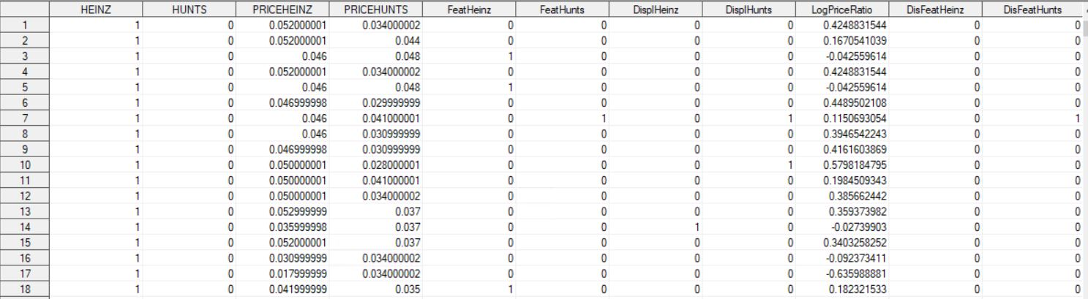

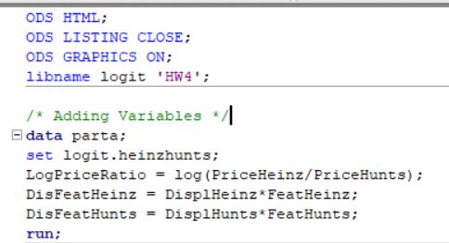



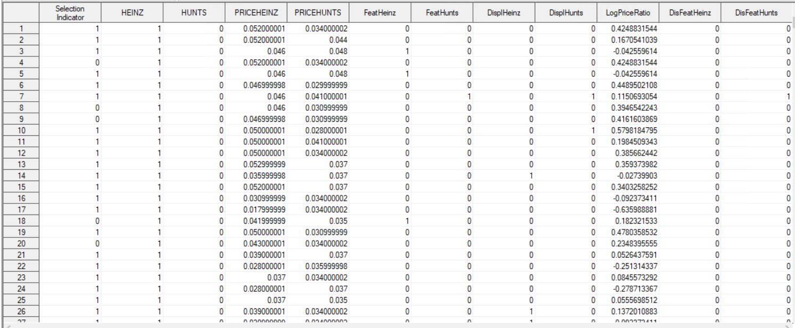

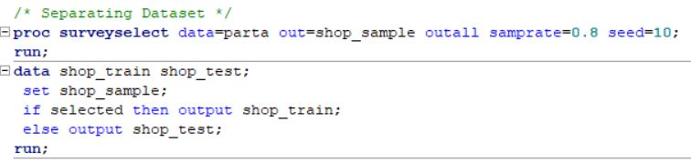



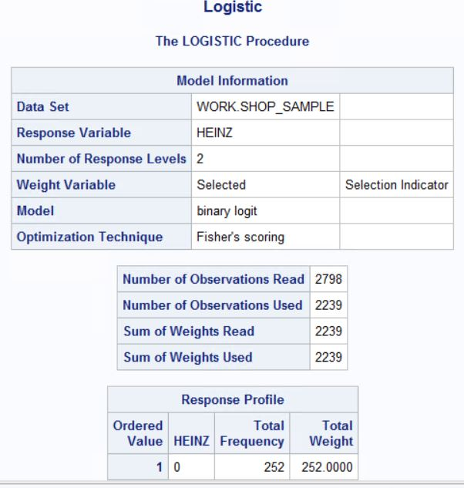





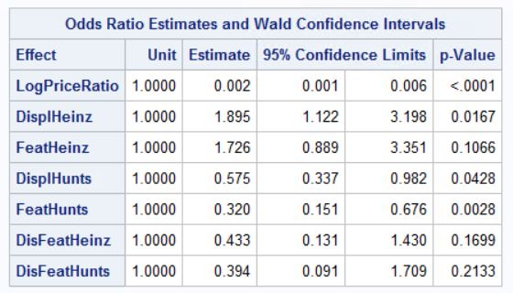

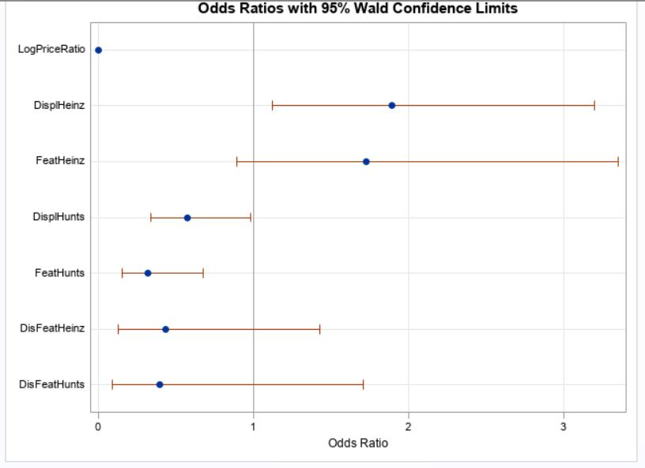

The parameters of the model are interpreted below:

LogPriceRatio = A one unit increase in LogPriceRatio decreases the odds of purchasing Heinz by 99.8%. This is statistically significant at 5%. It makes sense too as both Heinz and Hunts are close substitutes and price is a big factor in customer decisions. An increase in the price of Heinz would make customer switch to Hunt.

DisplHeinz = Having Heinz on display increases the odds of purchasing Heinz by 1.89 times or 89%. The result is statistically significant at 5%.

FeatHeinz = Having a store feature for Heinz increases the odds of purchasing Heinz by 1.73 times or 73%. The result is not statistically significant at 5%.

DisplHunts = Having Hunts on display decreases the odds of purchasing Heinz by 0.57 times or by 42.5%. The result is statistically significant at 5%.

FeatHunts = Having a store feature for Hunts decreases the odds of purchasing Heinz by 0.32 times or 68%. The result is statistically significant at 5%.

DisFeatHeinz = Having Heinz on display with a store feature decreases the odds of purchasing Heinz by 0.43 times or 57%. The result is not statistically significant at 5%.

DisFeatHunts = Having Hunts on display with a store feature decreases the odds of purchasing Heinz by 0.39 times or 61%. The result is not statistically significant at 5%.

For Heinz, display is more important than store feature (DisplHeinz is statistically significant while FeatHeinz is not). While, for Hunt, both display and store features are equally important to boost sales and statistically significant.



The change in the predicted probability that Heinz is purchased if LogPriceRatio changes from 0.3 to 0.4, and Heinz does not use a feature or display, while Hunts uses a feature of display is the difference between the workings below:

|  |  |
| --- | --- |
| Pr(Y=1)= | EXP(B0+x1*B1+x2*B2+x3*B3+x4*B4) |
|  | 1+EXP(B0+x1*B1+x2*B2+x3*B3+x4*B4) |
|  |  |
| Pr(Y=1)= | EXP(3.214+0.3*-6.0112+1*-.5529+1*-1.1403+1*-0.9322) |
|  | 1+EXP(3.214+0.3*-6.0112+1*-.5529+1*-1.1403+1*-0.9322) |
|  |  |
| Pr(Y=1)= | 0.2968 |
|  | 1.2968 |
|  |  |
| Pr(Y=1)= | **0.2289** |

|  |  |
| --- | --- |
| Pr(Y=1)= | EXP(B0+x1*B1+x2*B2+x3*B3+x4*B4) |
|  | 1+EXP(B0+x1*B1+x2*B2+x3*B3+x4*B4) |
|  |  |
| Pr(Y=1)= | EXP(3.214+0.4*-6.0112+1*-.5529+1*-1.1403+1*-0.9322) |
|  | 1+EXP(3.214+0.4*-6.0112+1*-.5529+1*-1.1403+1*-0.9322) |
|  |  |
| Pr(Y=1)= | 0.1627 |
|  | 1.1627 |
|  |  |
| Pr(Y=1)= | **0.1400** |

The change in probability is .1400 - .2289= -.0889.



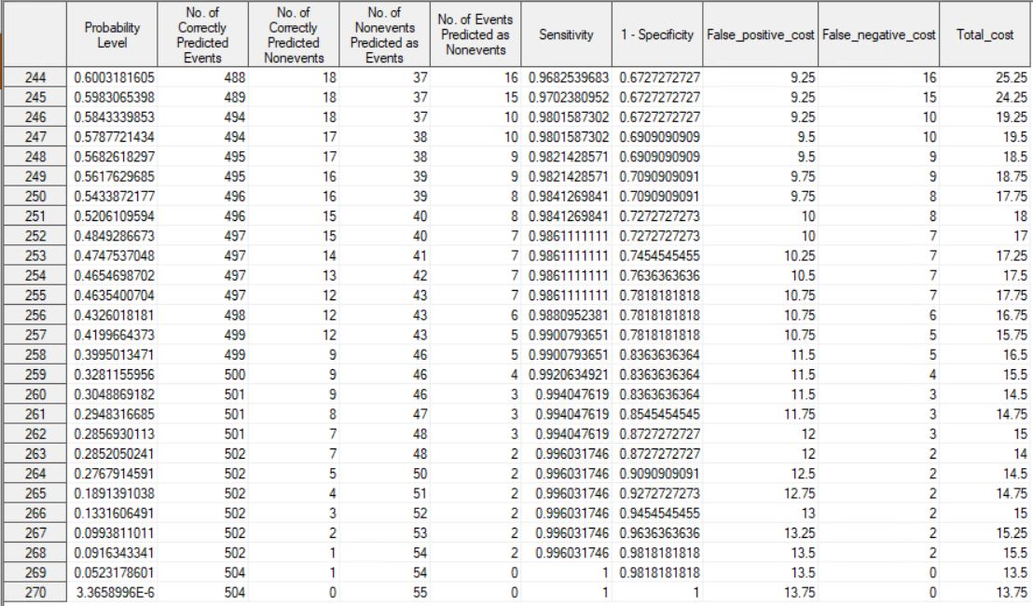

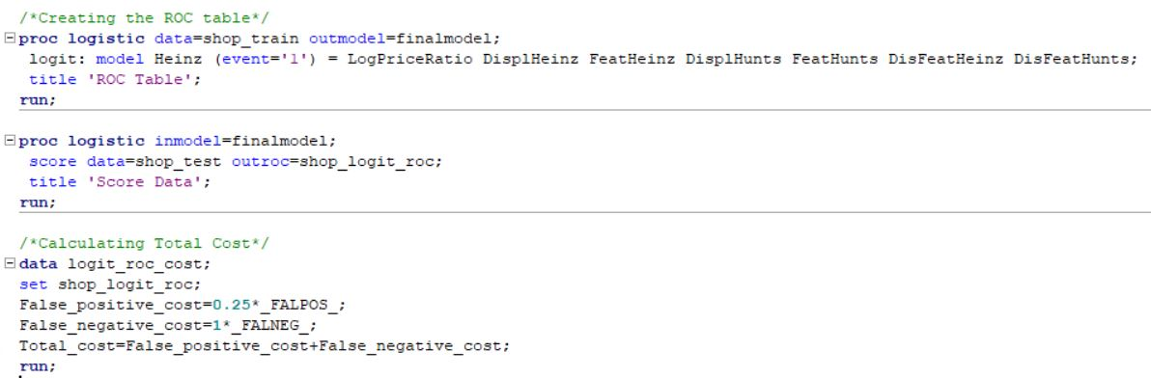

The optimal threshold probability that should be used to decide which customers should receive coupons is .0523, where the total cost of misclassifications is USD 13.5 (The relevant observation is row 269 in the above table). At that threshold, sensitivity is 1 and 1-specificity is .981.